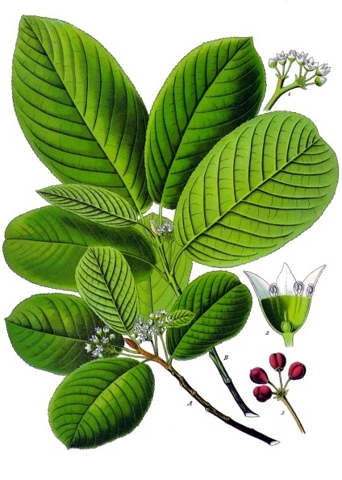

###### Cascara Sagrada

Monograph by: Christianna Ferri

**Scientific name:** Rhamnus pushiana DC

**Common names:** bitter bark, buckthorn, cascararinde, chittem bark, Cortex rhamni purshianae, purshiana bark, Rhamnus, and sacred bark

**Parts used:** dried bark

**Uses:** constipation, loss of appetite, hemorrhoids (some experts do not recommend treatments to get softer stools because it may encourage defecation in cases of hemorrhoids because it may increase irritation which leads to hemorrhoids. On the other hand, other herbalists prescribe this because although they may temporarily irritate them, it helps to expel feces so as a result they eventually have a beneficial effect on them), cholesterol

**Taste**: Bitter

**When to harvest:** Collected in the spring or early summer where it easily peels from the tree, and once stripped the bark must be aged for at least 1 year before use because fresh cut, dried bark causes violent vomiting and diarrhea

**Combines:** aloe Vera latex

**Ways to take:** To treat chronic constipation with cascara sagrada, put four teaspoons of bark in a one quart jar, fill to the top and let sit for at least one hour and drink up to two cups a day before the constipation is completely eliminated. Also can use in dry capsules, fluid extract, powder capsules or tincture (take according to patients terms of leaflet)

**Contradictions:** Documented to cause abortion and increase milk flow of breast-feeding women. Avoid use. Cascara's active substances may be excreted in breast milk, should also not be used by people with [Crohn's disease](https://en.wikipedia.org/wiki/Crohn%27s_disease), [irritable bowel syndrome](https://en.wikipedia.org/wiki/Irritable_bowel_syndrome), [colitis](https://en.wikipedia.org/wiki/Colitis), [hemorrhoids](https://en.wikipedia.org/wiki/Hemorrhoids), [appendicitis](https://en.wikipedia.org/wiki/Appendicitis), or [kidney](https://en.wikipedia.org/wiki/Kidney) problems.

**References:**

1. [**https://www.drugs.com/npc/cascara.html**](https://www.drugs.com/npc/cascara.html)[**https://en.wikipedia.org/wiki/Rhamnus_purshiana**](https://en.wikipedia.org/wiki/Rhamnus_purshiana)
2. [**http://www.botanical-online.com/english/propertiescascarasagrada.htm**](http://www.botanical-online.com/english/propertiescascarasagrada.htm)
3. [**http://healthybenefits.info/the-health-benefits-of-cascara-sagrada-herb/**](http://healthybenefits.info/the-health-benefits-of-cascara-sagrada-herb/)
4. [**https://www.mountainroseherbs.com/products/cascara-sagrada-bark-powder/profile**](https://www.mountainroseherbs.com/products/cascara-sagrada-bark-powder/profile)